Richard Roman

Hubert Walton

Ryan Grogan

Online Forms System

Currently Coastal Carolina University uses paper forms to manage course information data, and process student requests. The Goal of this project is to replace the manual paper form process for Coastal Carolina University with an online substitute which works in a similar manner. The objective is to streamline the forms process, increase efficiency, decrease time to completion, and achieve more accurate reporting, accurate record keeping.

Stakeholders

Professor Cox

Coastal Carolina University

CCU Students

CCU Faculty

Team members

Programmers/Developers

Information collection techniques

*Studying of the existing business procedures and forms*

We reviewed many if not all of the forms that Coastal Carolina University currently has from general permission to course repeat forms. These were valuable resources because we were able to obtain an understanding of the current business practice and procedures of the forms process at the college and the input and output of each of those processes.

*User Interviewing*

We conducted interviews at the school of those would be most likely to use the forms process as well as members of the team.

Analysis Model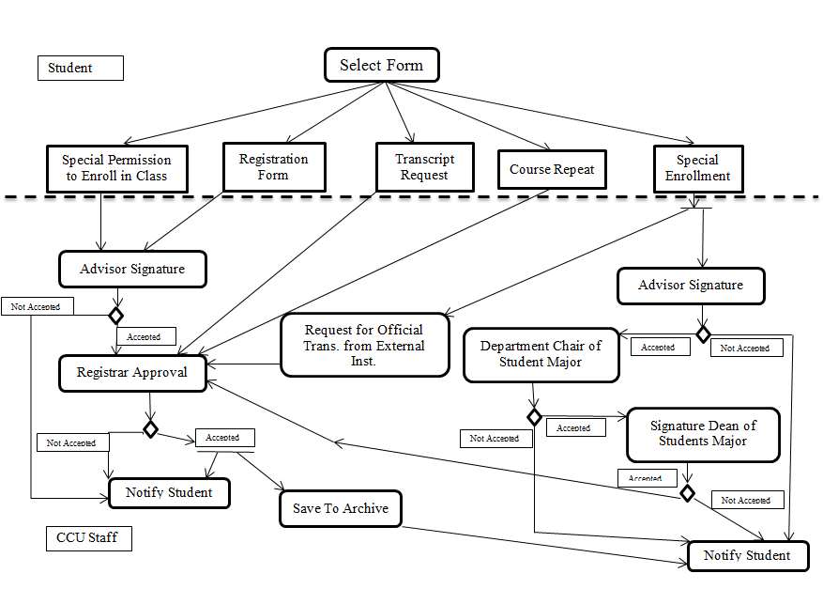

Rectangles are objects

Diamonds are decision points

Arrows are workflow

User stories

R1. As a Student, I want to be able to create a new form so that I don’t have to get paper copies.

R2. As a Student, I want to be able to delete forms so that if I no longer need to complete the form I can remove it.

R3. As a Student, I want to be able to search and retrieve forms so that I can view my history.

R4. As a Student I want to be able to edit the form so that I can make corrections.

R5. As a User, I want to be able to request assistance so that I can get help if I got stuck filling out form.

R6. As User, I want to be able to view form history so that I know when the form has been completed.

[EPIC]R7. As a Faculty member, I want to be able to send back forms to the student, so that corrections can be made.

R7A. As a faculty member, I want to set the number of corrections needed to be made.

R7B. As a faculty member, I want to specify where in the form correction need to be made.

R8. As a User, I want to be able to save forms to the system I’m using on an external device so that I have records of each form.

[EPIC]R9. As a User I want to be able to obtain status reports of each form, so that I know when the form is either ready to be signed or completed.

R9A. As a user I want to be able to see status of each step in the process, so that if something goes wrong I can see its last known location.

R10. As a User, I want to be able to access the online forms system from any mobile or pc device [Portability].